Teaching & Learning Policy

(SEND)

Wheatley Hill Community
Primary School

Author: Alan Scarr & Joy Hodgkinson
Head Teacher: Alan Scarr
Chair Of Governors: Jayne Dinsdale
Date Written: September 2021
Adopted by Governing Body: September 2020
Date for Review: September 2022

Why?
“A caring, inclusive school at the heart of the local community. We believe that quality learning takes place both inside and outside the classroom.”

How?
The Wheatley Hill Way - We care for each other; we look after our learning environment and we always do the right thing.

At Wheatley Hill Primary, we believe that our Teaching & Learning approach should enable our pupils (regardless of SEND) to function meaningfully and as independently as possible in the community.
In order to become independent, we want our pupils to benefit from methods and styles of teaching that stimulate and development higher order thinking skills.
What we seek to do within the classroom is provide individualised, open-ended tasks with a focus on developing the ability to work independently, problem solve, discuss, collaborate and think imaginatively to foster the following “Creative Behaviours”:
- Questioning and challenging
- Identifying and solving problems
- Envisaging what might be “What If”
- Exploring ideas, keeping options open
- Reflecting critically on ideas, actions and outcomes
- Making connections and seeing relationships
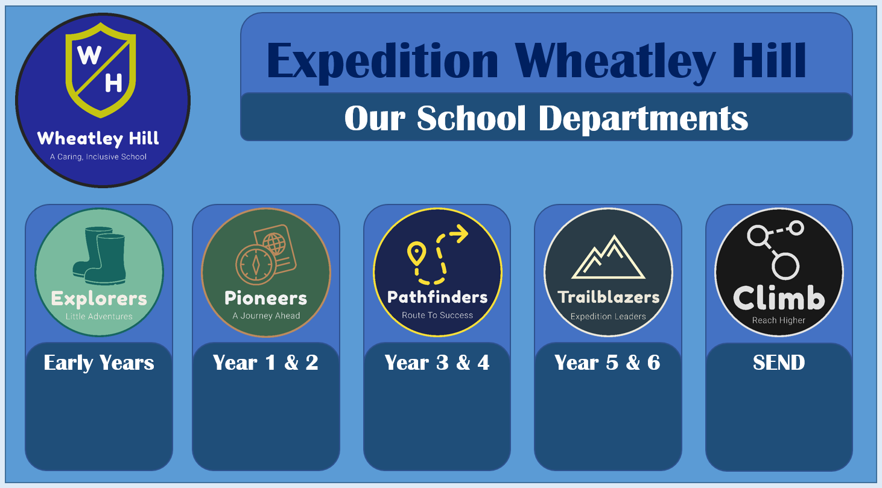
Our School Departments

The Climb Project

Wheatley Hill Primary is a caring and inclusive school, at the heart of the local community, where learning takes place inside and outside if the classroom. Wheatley Hill is not only a very successful mainstream primary school, but is also home to a specialist SEND department, caring for children with a range of complex needs, such as: Autism, Cerebral Palsy, Down Syndrome, Speech and Language Difficulties and Disorders, Global Delay etc. This exciting specialist provision is called ‘ The Climb Project’.

The Climb project now has over 60 children with EHCPs and top up funding, in order to support their complex needs and provide the necessary provision needed for each individual child. All of these children have a personalised timetable, individualised curriculum and specialist inventions to ensure that their needs are met to the highest standard. Our specialised provision, in Wheatley Hill, has rapidly grown within the last 12 months and now includes 8 base classrooms within the school!

Our current Base Camp set up:

Explorers base 1 – Nursery children
Explorers base 2 – Reception children
Pioneers base 1 – Year 1 children
Pioneers base 2 – Year 2 children
Pathfinders base 1 – Year 3 and 4 children
Pathfinders base 2 – Year 3 and 4 children
Trailblazers base 1 – Year 5 children
Trailblazers base 2 – Year 6 children

The Climb staffing structure:
Deputy Head teacher, SENDCO and Head of the Climb Project | Miss. Joy. Hodgkinson
Lead teacher | Miss Kimberley Graham
Teachers | Miss Levington
SEND Room lead staff | Emma  Clare Anderson  Christine Wigham  Musu Gurr  Tanya Carney  Danielle Rankin
SEND support staff | Rachelle Hann  Phoebe  Charlotte Dent  Megan Surtees  Ellie Hutton  Jatindar  Michelle  Jill Barker  Zena Ebdon  Ashleigh Chadwick  Danielle Ragan  Linda Anson  Victoria Grainger  Kayleigh  Kay Leigh  Rebecca Alvey

Learning is enhanced through the …effective use of additional adults
- Each base has approximately 3 or 4 members of room support. These members of staff are clearly directed by their teacher and room leads to support the children in their base.
- Room support staff are fully engaged with pupils on the carpet and tables during lesson times. They are not photocopying work, sharpening pencils or sticking work in books during learning time.
- They are clear about who (or which group) they are supporting and why.
- Daily Planning & Work Systems are shared in advance with teaching assistants and other adults supporting our children.
- They sit next to the pupil/pupils they are working with, quietly engaging the pupils, encouraging pupils to use the Work System or using other resources, e.g. numicon to facilitate learning.
- They are involved in assessing pupil’s understanding and feeding back to the teacher.
- Room support staff to annotate in books to indicate support.

Staffing Specialisms:
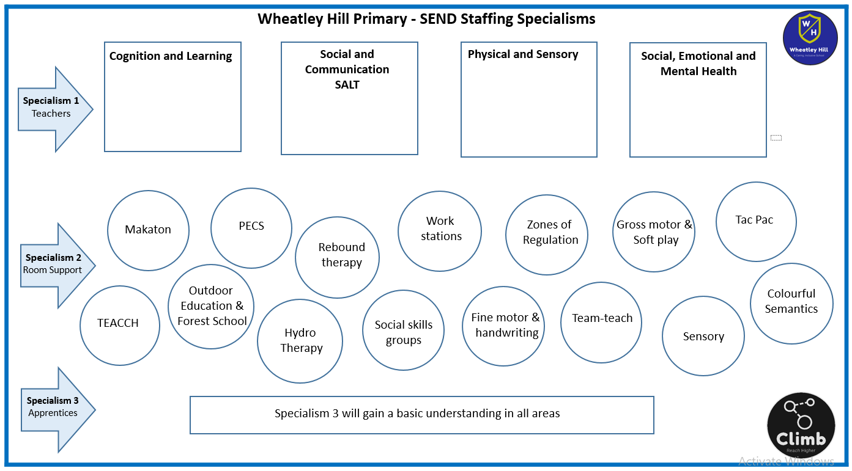
At Wheatley Hill Primary we are keen to develop our staff, in order for them to be trained to a high standard, enabling them to support our children with differing needs. Teachers in our SEND department each lead one of the four broad areas of need. Room support staff are trained and developed to become a specialist in one of our provision offers. They lead on this area, take part in training and offer support to other staff who need it.
Joining the Climb project
When children first join the Climb Project, a series of assessments are carried out around the four broad areas of need: Cognition and Learning, Communication and interaction, Physical and sensory and Social, emotional and mental health. Following these careful assessments, a package of support is devised for each individual child and the curriculum is devised to suit their needs.

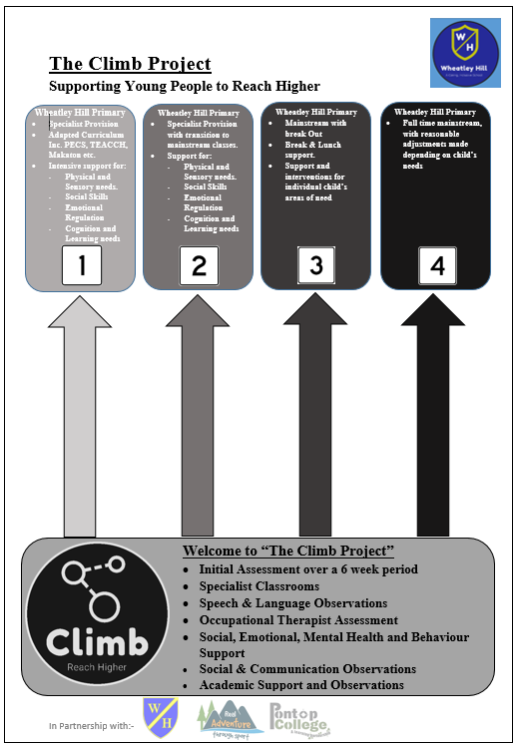

Individual timetables
Once the children are placed on a ‘reach higher pathway,’ they are allocated to a base classroom, depending upon need, age and interests. A timetable is then devised to ensure provision is effective and appropriate to them. No two timetables are always the same, some may be similar, but we recognise that all children have different needs, therefore need different provision and intervention and an adapted curriculum.

Examples of personalised timetable in Base Camp Reception:

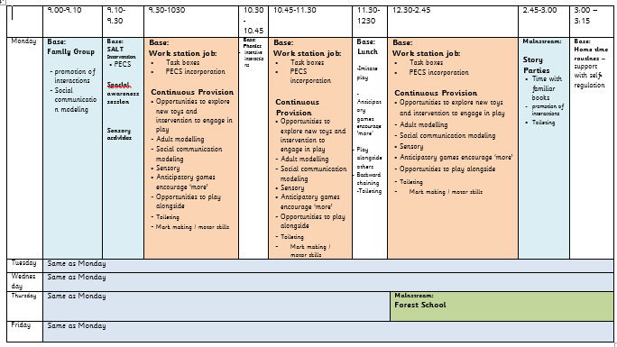

Examples of personalised timetable in Base Camp Year 6:

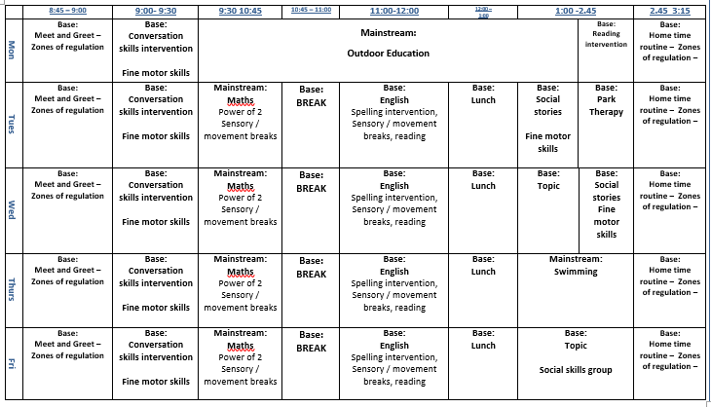
*Examples of timetables are saved on staff shared area
Deliver Quality First Teaching

All lessons, across our school, should include the following key elements, to ensure high quality teaching and learning. New teachers to our school will receive training, to ensure they fully understand these elements, and to enable them to embed them in their everyday practice.
All lessons have…Clear Learning Objective
- Lessons have ONE clear learning objective.
- Learning objective is shared orally, and displayed at the start of each lesson using the school template to ensure consistency across classrooms.
- All complex language is explained and discussed.
- Learning objectives are not muddled up with the context of the lesson.
- The learning objective is written or stuck into children’s books depending upon pupil needs.

For learning objectives to be shared effectively, teachers must:
- Use the sentence stem – By the end of the lesson you will be able to…
- Verbally, use ‘so that’ to add context following you LO.
- Make the learning objective precise to the intended subject i.e. don’t confuse subjects.
- Use child-friendly language, or clearly model and explain complex language – there is little point in sharing learning objectives if children don’t understand what you mean.
- Refer to them at the start of the lesson, during the lesson and during the feedback session.
- Children must know exactly what they are going to learn, and what is expected of them, by the end of the lesson.
- A consistent approach to the introduction of LOs across school.

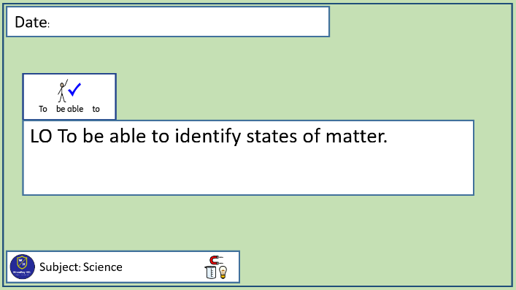
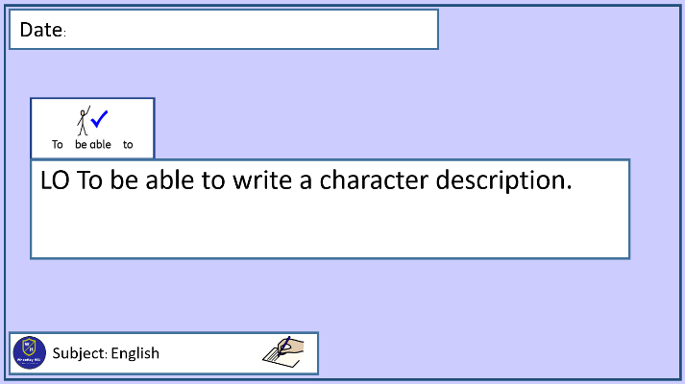

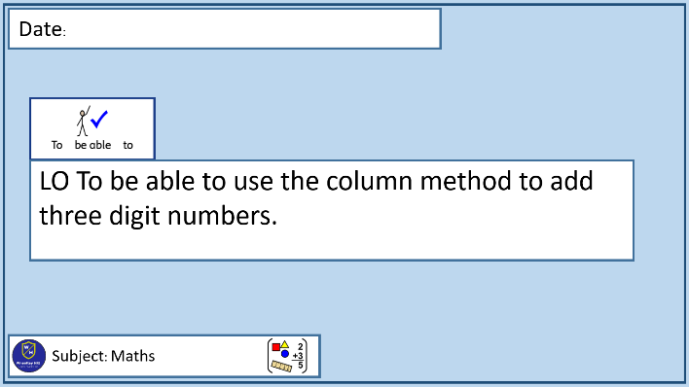
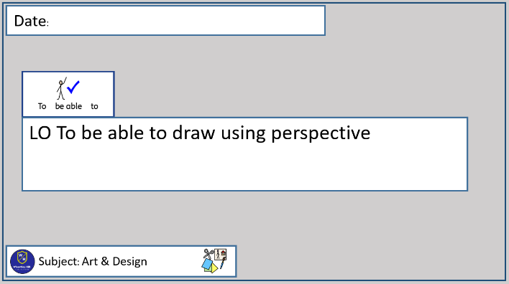

All lessons have… a Work System
- All pupils are clear about ‘what work’ they need to complete – the Leaning Objective.
- All pupils know ‘how much work’ they need to complete.
- Pupils need to know when their work is ‘finished’.
- The pupils will know what to do ‘next’ – check, challenge & choice.
- Work system is displayed for the children to follow, during the lesson.
- Children use the work system to track their progress towards the LO.
- Children are reminded of the work system during the lesson.
- To support teacher assessment, work systems will be stuck into pupil books for extended writing.

Examples of progression in work systems:
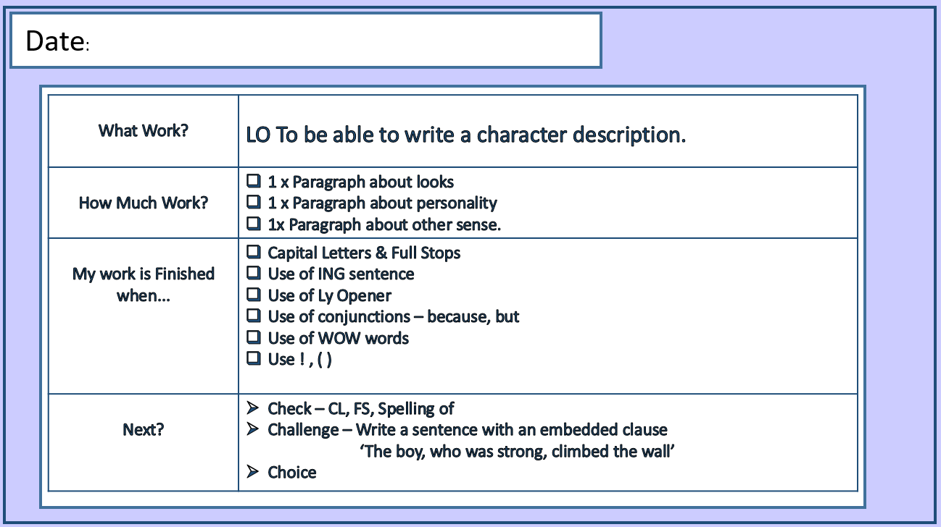

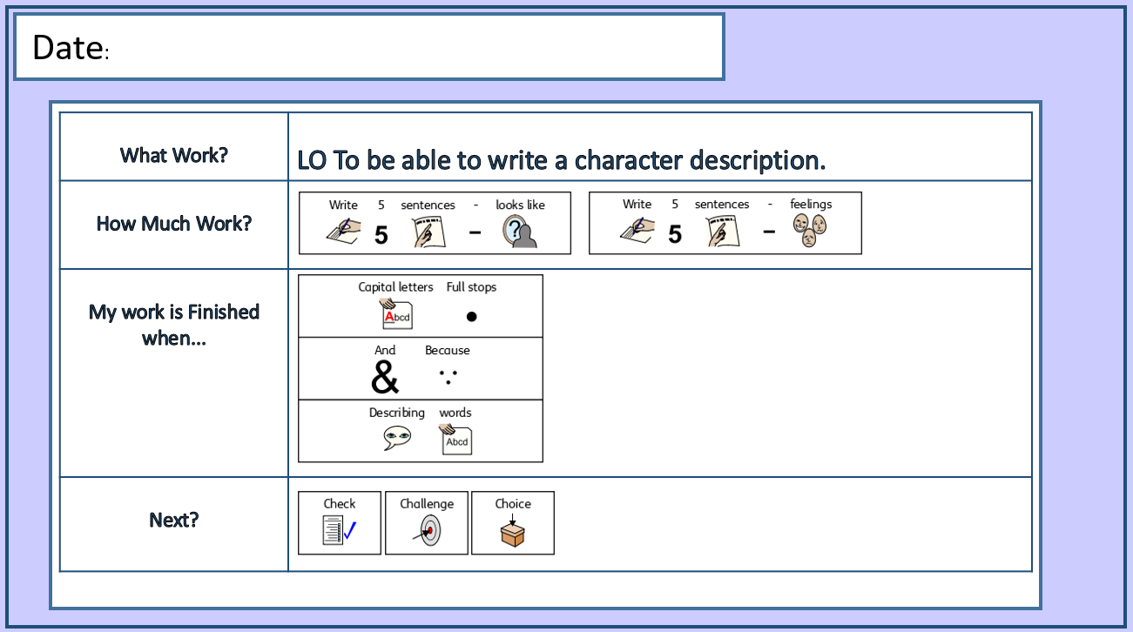

All lessons have… an adaptive approach to support all learners
- In all lessons, children are challenged appropriately.
- Pupils will be supported through a range of learning styles (Visual, Audio, Kinaesthetic) as well as specialist SEND support systems such as colourful semantics, PECs, TEACCH etc. Children may require a different Work System within mainstream classroom sessions. This needs to be carefully planned before the lesson.

All pupils are…Actively engaged in learning and work co-operatively
- Pupils are actively engaged, during all parts of the lesson – teachers take into account children’s concentration span and ensure pupils are not sitting passively for long periods e.g. movement breaks, episodes of teaching (movement breaks can be as simple as a transition from carpet to tables).
- Opportunities, where appropriate, for the purposeful use of ‘talk partner’ are regular features in all lessons (Think/Pair/Share).
- Teachers regularly refer to the Three Rules of Good Listening – Sitting, Looking & Thinking. (Communication Trust)
- Mini whiteboards, or jotters are used for short bursts of activity, to develop understanding and to ensure children are active and engaged during the lesson.
- Visuals, artefacts, auditory input are all used creatively, as a way to enhance learning including talking tubs, curiosity crates, floor-books and working walls.
- Children & staff help and encourage each other (We care for each other)
- All adults promote positivity and encourage participation throughout.
- Teachers intervene throughout the lesson to address misconceptions, alter scaffolding or set higher levels of challenge.

All pupils receive regular and clear …feedback which enhances learning
- We encourage active marking and instant individual, group or whole class feedback. Instant and precise feedback is proven to have a much greater impact on pupil learning than after lesson marking.
- Active marking & feedback takes place during lesson rather than waiting until the end of a session. This approach allows extensions or corrections to be set and actioned immediately removing the need for follow up tasks etc.
- When marking children’s work, the main focus is on ensuring the learning objective through the use of the Work System has been met. Pupil work is highlighted, or commented on in line with the Marking Policy.
- Although some marking will take place after lessons, this delayed feedback should still be purposeful and precise to support future pupil learning.
- Individual targets are updated regularly for Maths and Writing when needed – these are displayed in the front of their books and the children refer to them during lessons. These targets are a worked model of sentence types to be worked on.
- Encourage pupils to feedback to others & reflect on what they have learned and what has helped them to learn.
Use prompts like:
    - What did you do today that you found most helpful when you were learning?
    - What did you do today that you found less helpful?
    - If you had to do the task again, how would you do it?
    - If you had to give one piece of advice to someone tackling the same task, what would it be?

Learning is enhanced through the use of… Positive Behaviour Management
Effective, positive behaviour management is used to foster a positive learning environment in the classroom. When working with children with differing levels of SEND, it is important for staff to be clear around what is ‘chosen behaviour’ and when a child is displaying behaviours due to their SEND needs not being met. This becomes clear once you get to know your pupils. It is vital that staff really get to know their children and understand what may be a trigger for them and which strategies work to support de-escalation.
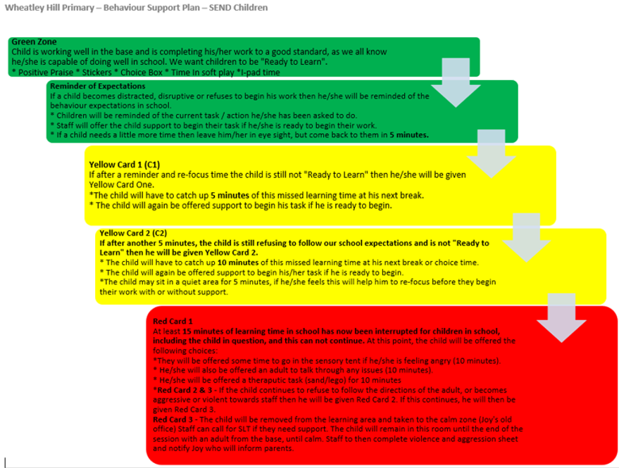
Some of our children may need an individual positive behaviour plan as shown below:
*See Risk Assessment folder to complete Violence and Aggression tracker. These need to be scanned and added to CPOMs at the end of the week.
Note –
It is important that after a child has had a melt-down, or has reached a crisis point that restorative work takes place afterwards. It is pointless trying to talk to a child about their behaviour while they are in crisis.
Reflection time is very important to encourage the child to recognise and understand their behaviours. This can be done in the form of social stories using puppets / Lego / characters etc.
Staff should consider:
- What was the child trying to communicate to me?
- What would you do differently next time to support the child or avoid/ prepare for the trigger?
- What support did you use or could you use in future? E.g. Now/next boards, visual prompts etc.
Wheatley Hill Primary – Our Model of Excellent Teaching & Learning
Basic Life Skills
Focus on developing resilience; independence and the ability to manage risk.
Self Regulation Focus on self help strategies, meta-cognition and emotional intelligence.
Language Acquisition
Focus on Developing Language, Vocabulary and communication.
Feedback Focus on effective feedback that is specific, accurate and clear. Challenge pupils through feedback.

Amaze!
A Wow Experience – trip, visit or visual

Discuss It!
Who, What, When, Where, Why, How, What if?

Model It!
The Task – Planning, implementation & improvement

Support It!
Scaffolding – Mind Maps, Writing Frames, Plans
Remove – Gradually Remove Support

Perform It!
Complete Task Independently

Teaching & Learning at Wheatley Hill Primary – Ready to Teach
A Typical Day
8:30 – 8:45 – Prior to Pupil arrival - Classrooms are ready!
- ALL workspaces are clear.
- Teacher work/ files put away.
- Continuous provision is ready for use (if applicable).
- Support Staff are briefed.
- All morning photocopying complete & resources prepared.
- Room visual timetables are set up and in view for the children
- Individual timetables / now and next boards are set up on the children’s workstations ready for their arrival

8:45 – 9:00 – Morning Meet and Greet (done regardless of what time the child arrives)
- Staff are notified by radio that your children have arrived at main reception
- A member of staff meets and greets the child in our main entrance
- Children hang their coats up and take off their name/photo label to take into the classroom.
- Children use their name / photo label to self-register using the Zones of regulation display in the classroom
- Staff support any children who are not in the green zone
- Children are encouraged to sit with their group either on the carpet or at the big table
- This session focus’ on the use of ‘talk’
- During this session the children are encouraged to ‘talk’ about what day it is, what the weather is like, who is here today etc. Staff talk the children through their day using the class visual timetable to support

9:00 – 10:15 Carousel of Handwriting / Fine Motor /Maths intervention / reading / phonics
Handwriting / fine motor:
- Handwriting / fine motor activities pre-written or set up before pupils enter the room.
- Pupils enter the room in quietly to work.
- Staff members actively engage pupils during handwriting and fine motor sessions.
- Staff members clarify language and discuss sentence types, if appropriate.
- All linked to current text type / class novel / topic / new spelling words.
- Sensory / movement breaks included
Maths intervention:
- Children work through their power of books with support when needed
- Times table intervention
- Basic skills
- Number formation
- Sensory / movement breaks included
Reading / phonics:
- Children will read 1:1 to a member of room support and the adult will complete their reading diary. Accelerated Reader Programme will be used during these sessions.
- We use Read, Write Inc phonics program. This will end before the children start year 3 and they will move on to sight words and flash cards
- Sensory / movement breaks included.

20 minute allocated slot (during carousel time) - Gross motor carousel in the gym (Tues, Weds, Thurs)
- Gym is set up with equipment ready for the children to access, depending upon their needs.
- The set up in in the style of ‘circuits’ with an activity at each area spread around the gym and a visual image for the children to refer to if needed.
- A visual timer can be used and the children move around onto the next activity.
- Staff are ENGAGED in the carousel, not sitting on benches, and encouraging and supporting the children during the session.
*See ‘How we support Gross Motor at WHP’ Document

10:15 – 10:30 – Morning breakfast snack
- Children sit around the big table for mid-morning breakfast snack
- The purpose of this session is to encourage social skills and appropriate table manners, as well as supporting sensory needs by offering a range of different textured snacks.
- Children will be offered a different healthy snack each day and encouraged to ‘talk’ about the snack.
- Children should not be offered biscuits or crisps every day and certainly not a whole packet. One day may be chopped up banana and another may be apple or a crunchy option
- Children can have a drink with their snack.
- To promote independence, children should be encouraged to help set up the snack table.
- All staff should be actively involved
- Receipts should be kept from staff who purchase the snack items and handed to admin who will reimburse once the total cost is £20

10:30 - 11:15 – Maths & Feedback (Aprox Times)
- All children access quality first teach with a practical element and photos taken to capture learning
- At least 3 Maths lessons per week will be captured in their maths books
- Clear LO, Work System and Scaffolding
- Children may access their task boxes
- Children may need to be taught 1:1 to complete their tasks
- Where appropriate, children will work in a group at the big table before accessing their work station for INDEPENDENT work
- Sensory / movement breaks included

11:15 – 11:30 – Playtime
- Pupils are escorted onto the sensory garden / yard / field / soft play (timetabled) by base camp staff
- Any pupils losing time will remain in the classroom – discuss behaviour choices and ways to improve Only in extreme cases should a child lose their WHOLE playtime and this should be cleared with Joy. (See Positive Behaviour Policy)
- Staff should be actively involved and engaged with child’s play. Staff should not be standing together talking or sitting around on benches in the gym.

11:30 – 12:15 – English & Feedback Colourful Semantics
- All children access quality first teach with a practical element and photos taken to capture learning
- At least 3 English lessons per week will be captured in their English books
- Clear LO, Work System and Scaffolding
- Children may access their task boxes
- Children may need to be taught 1:1 to complete their tasks
- Where appropriate, children will work in a group at the big table before accessing their work station for INDEPENDENT work
- Sensory / movement breaks included

12:15 – 1:15 – Lunch Time
- Pupils have 30 mins in the base classroom to eat their lunch
- Pupils on packed lunch will be encouraged to get their own packed lunch at bring it to the big table
- Children who feel confident to go to the dinner hall to collect their food can. Staff will collect the children’s food from the dinner hall for those who wouldn’t cope entering the dinner hall.
- Children will be encouraged to use knives and forks and show appropriate tables manners whilst having dinner
- After eating, the children will have 30 minutes play time which will be allocated to the field/ yard/ soft play or sensory garden.
- Any pupils losing time will remain in the base for some of their break – discuss behaviour choices and ways to improve. Only in extreme cases will children lose their WHOLE play time – this needs to be approved by Joy.
- Following lunch, Self-Register Zones of Regulation check in. Support any children who are not in the green zone.

1:15 – 2:00 – Core Skills including Social Skills groups/ Comic-strip conversations/Zones of Regulation workshops / Sensory time / Lego Therapy etc.
- Ensure all children are settled.
- Pupils enter the room quietly to work.
- Staff members actively engage pupils during session
- This leaning should be captured in the children’s journals.
- Sensory / movement breaks included

2:00 – 2:45 – Foundation Subjects / Science / RE
- All of these lessons are purposeful, well prepared and resourced.
- Curriculum progression documents are effectively used to plan & deliver high quality sessions.
- EHCP and SEN support plan targets are taken into consideration when planning for these sessions
- Precise Links are made to the classroom topic where possible, otherwise subjects are taught discretely.
- Have a clear LO and Work System.
- Learning is captured for the class floor-book, pupil workbooks and individual black journals.
- Opportunities to write captured moments and longer observations are taken.
- Sensory / movement breaks included

2:45 – 3:00/3:15 – Review of the day
- Opportunity for sensory story parties and shared class novels, if appropriate.
- Ensure classroom is tidy
- Home School Diaries complete
- Resources put away accordingly
- Zones of regulation
- Circle Time
- Speaking & Listening Time
- All children happy as they leave!

*Time are approximate and may need to be altered depending on timetabled gym times / outdoor times and also may need to fall in line with those children joining in the mainstream following the autumn term.

The Right Start – Key Considerations to get the off to the best start!
At Wheatley Hill Primary, we talk a lot about ensuring children are “Ready to Learn”. Now is the time to look at what we must expect from ourselves to enable us to get the most out of our pupils. We must be “Ready to Teach” and if we focus on that then more pupils will be “Ready to Learn”.
Consideration 1 – The needs of your pupils
EHCPs – Have you read all of your pupil’s EHCP’s and know the long term outcomes they are working towards?
EHCP’s are formally reviewed once per year and are a working document which you can write on and update informally throughout the year. Do you know the date of the child’s review? If not, check this with the SENDCO. Prior to a review, children complete a power point about themselves, which they share during the meeting with parents and other professionals. You can find the template on the shared area.
SEN support plans need updating each term and shared with parents. These are updated in July ready for the children starting in their new year group in September. Again at Christmas, then Easter. Support plans are put into the child’s learning journal and referred to, worked towards and highlighted when achieved, with the learning captured to show the progress.
Does your classroom environment show that you have thought about the provision needed to meet the children’s needs and outcomes outlined in the Support plans and EHCPs?
Home / school diaries – have you read them for daily updates from home?

Consideration 2 - Prior to Children’s Arrival
This is about getting your school day off to the right start. Prior to the children entering your classroom from 8:45am you need to be prepared and organised. For your morning session, all photocopying, resource prep and set ups should be completed before children start to enter you room.
Preparations for you morning sessions can be completed in the morning or the evening prior. If you wish to prepare lessons, conduct photocopying, make resources or set up task boxes then we recommend you consider your arrival times at work to ensure you have enough time in order to be ready for pupil arrivals at 8:45am. If preparing on the previous evening, so you don’t have a busy morning or you have childcare arrangements, then you must still arrive in school in good time. Most staff in school contractually start work at 8:30am; however, this means you are in class working and not entering the school and heading for a coffee or a catch up with colleagues. School is open until 6pm on an evening so we welcome staff to socialise with peers as frequently as possible outside of your classroom working duties.
In school, we will be focusing on precision in all aspects of our teaching. We expect our staff to consider this in all aspects of their duties in school –
- What is the purpose of…?
- Am I clear in what I expect? Do the children know? Do my colleagues know?
- Can I squeeze any more learning out of this task, activity, moment i.e. practicing x tables while lining up, using phonics cards while entering the school from play time.
- These thoughts do not just apply to your classroom – transitions, lining up etc. are all reflections of the classroom practice.

When we consider precision in our morning set up, we must consider:
- Is my base classroom tidy – pupil work stations, staff work spaces, work tops, big tables, floor spaces? If not, why not?
- Are pupil resources available – enough pens, pencils, rubbers etc?
- Are your areas set up – work stations, continuous provision, break out spaces? You must be prepared to support our most vulnerable learners.

Consideration 3 – Morning meet and greet –This is the first face – face interaction with pupils for yourself and your classroom team. We do not know what has happened to our pupils before they have arrived in our care – we cannot presume that all of our children will be Ready to Learn the moment that they step through the door. Your first interactions with pupils of the day could be the moment that makes a child feel safe and ready to engage or a poor first interaction could be the tipping point that sends a pupil into a downward spiral for the rest of the day.
We will greet our pupils when they enter our school. A sincere welcome and acknowledgement of the pupils can be enough to get your day off to a good start. However, you must also be aware that children can read your body language & tone – if you aren’t sincere then maybe you’re not “Ready to Teach”. We expect staff to develop professional, caring & compassionate relationships with pupils – there is nothing worse than children thinking staff don’t “like” them – many of our children struggle in their personal lives to find consistent, caring relationships so we must provide this – our pupils trust is hard to gain at times – but always easy to lose!
At this point, the pupils have started to enter the classroom and they should have followed the clearly established system you have in place to ensure coats and bags are stored accordingly. To ensure the children follow the system and care about their possessions, do you check the cloak area? Do you monitor this space? What do you do about coats on the floor?
As the children begin to filter into class and you greet them, we need to consider your classroom routines at this point. Will the children find their Handwriting books on their desks ready? If not, what decisions have you made? What do the pupils do with reading records? Any monies? It’s all about consistency – the same routines happen everyday.

Consideration 4 – Carousel - Handwriting / Maths intervention / phonics / reading - Consideration needs to be taken around how you will set up your carousel. Ideally, each adult in the room will take the lead on each activity.
Maths intervention - may include Power of 1 or Plus 2 intervention, times table practice or basic skills. Speak to our maths coordinator if you need any support with this.
Handwriting / fine motor - we will be modeling high quality handwriting to the pupils offering instant feedback and driving improvements through our high expectations. We will incorporate HFW, common exception words and embed opportunities for pupils to refine their phonological knowledge. See English Section for handwriting progression. HW will be precise it is not a copying procedure. Handwriting in KS2 will incorporate the use of sentence types pupils are working on i.e. Fronted adverbials. HW will also incorporate the current spelling rules being taught as well as consolidating previous spelling rules. Challenges may be set by punctuation being missed, words omitted etc. We will also use this HW as an opportunity to introduce new challenging vocabulary (tier 2) and also to develop subject specific / topic vocabulary (tier 3). A strong practitioner could also use HW as an opportunity to pre-expose / pre-teach some high quality sentences that the children could steal for their English lesson. An excellent practitioner is always making precise impactful learning links.
Fine motor sessions. Those pupils who struggle with letter formation, need a multi-sensory approach to handwriting. They need to have a carefully planned range of activities to support this.
*See ‘Supporting children with Fine Motor Difficulties at WHP
Phonics - Children in EYFS & Key Stage 1 will use the Read, Write Inc phonics program. Direct phonics teaching will take place during morning carousel.
High quality RWI sessions require a range of resources in order to achieve the greatest pupil outcomes including word cards, Fred Frogs and magnetic letters etc. All resources for RWI sessions must be pre-prepared before the session starts so valuable time is not lost during sessions.
RWI is a prescriptive approach to the teaching of phonics and early reading. This approach must be followed and not deviated from as this could create gaps in pupil understanding when they transition groups. The quality of phonics teaching will be monitored by the English Lead.
Our intention is for all children to have completed RWI phonics by the end of Autumn Term Yr 2. Children with SEND, who are struggling to make progress using a phonological approach, will transition to a whole word approach in KS2.
Reading Session - During carousel, children will have time to read to an adult. Ability appropriate books should be used and out ready before the children read. Staff should not be looking for books at this point, they should be prepared and ready for the children prior to the session. Staff should complete the reading record book for each child. Teachers will ask the children questions about what they have read in line with their reading assessments and focus’ and use this information to complete reading assessments for the children. In the cases where children are non – verbal or cannot yet read, they should still be encouraged to share a story with an adult. Children can then be asked things like ‘Can you point to….’

Consideration 7 - Outdoor Education and Forest School at Wheatley Hill
Children will participate in regular outdoor learning opportunities and will be off-site for these periods. The educational visits will be managed following the guidance in the staff handbook.
Each base will have access to a vehicle and a member of staff who can drive. Outdoor Ed in the mainstream will happen on a Monday, Tuesday and a Wednesday. The plans for this will be displayed on our big planning board and staff can sign their base up to join, if the activity is appropriate for the children with SEND.

It is expected that the members of staff attending outdoor education will capture learning through observations, captured moments and learning stories – a pic collage will not be acceptable. Staff attending Outdoor Ed will have the time upon returning to school until 4:30pm to work in their observational write ups and record them in the individual black journals AND base floor books

Forest school, beach school and Outdoor Education. The plans for these outdoor learning experiences will be displayed on our big planning board and staff can sign their base up to join, if the activity is appropriate for the children with SEND.

Consideration 8 - Behaviour
Children should not be out in corridors or leaving the classroom without instruction. The things which are happening in our classroom should be so exciting and engaging for our pupils that they WANT to be in the classroom and are eager to see what learning is taking place. If a child is having a moment, due to a SEND need not being met, we need to deal with this appropriately using de-escalation techniques and put something in place to support the child.
If a child is beginning to get in a heightened state, we would first encourage them to their work station to have 5 minutes in their choice box, if this doesn’t help, a safe space may be required to support the child, until they are back in the green zone and ready to learn.
*See above SEND individual behaviour plan

Consideration 9 - Movement and transitions around school
Transitions around school should be planned and purposeful. Children who struggle with transitions need support when transitioning and need to be prepared for them. Some may need practical objects which are from their now and next boards to take with them to their next area. Some may need a visual card or a photograph. Others may need ear defenders or earphones with quiet music when they transition. This depends on the needs of the children which you are working with.
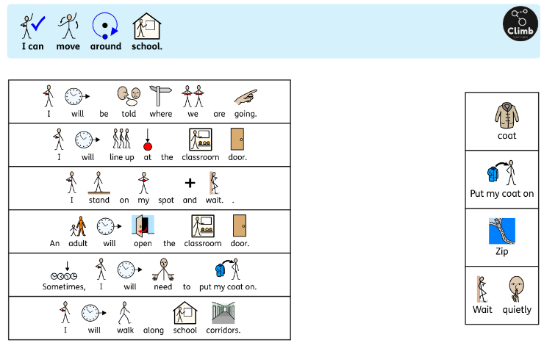
Children can be supported by using a visual prompt or match back activity, for following instructions as shown below:

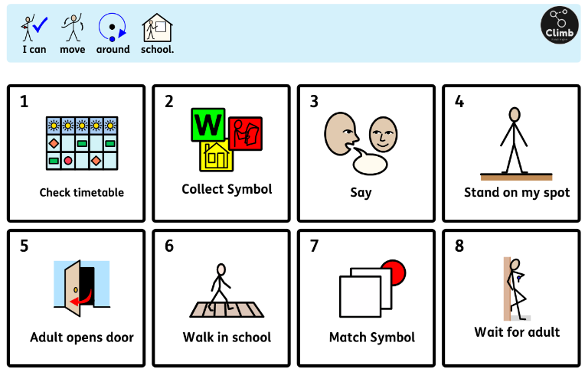

*For more info see ‘The TEACCH Approach at WHP’ document

Our Base Classroom Environment
Across our school, we aim to ensure that all classrooms, group learning areas and whole school areas are spaces that everyone can use to learn and be proud of.
All classes across the school should have:
- A communication friendly base classroom - Calm colours and a strong emphasis on natural materials and elements – the reason for this is because many of our children can become over sensitive to bright colours so a calming environment is more suitable to learning. We value natural materials and plants because these are “real” and we encourage children to celebrate and protect our natural world. Classrooms will have a space, where pupils can talk with peers, reflect on learning or support their behaviour and emotional regulation.

- A quiet space including a dedicated area, which supports Reading for Pleasure / Topic Specific Books / Accelerated Reading System - These spaces will provide a quiet learning environment for pupils with additional needs and will be set up in line with the needs of the pupils in your class. Classrooms will also have a range of books that children can choose to read for pleasure during ‘Choice’ time. Topic / Curriculum specific books will also be available and could include artefacts, which pupils can use to answer questions or study further about topics. Additional items could also include puppets, role play characters and story sacks. Classrooms will have a reading area, where their AR books will be available for pupils to access. This area will be organised, well presented and promote the love of reading.

- A group table – Each base will have a group table for ‘big table sitting’. This can be used for group work and daily interventions with the children. This table can be used for lunch time.

- Work stations - Children will have work stations for INDEPENDENT work. Younger bases may only need 1 communal work station, where as the older bases may need one per child. Please refer to the work station policy to set up your workstations.
*See ‘Work stations at WHP’ for further information.

- Continuous Provision / Practical Learning appropriate to the ability levels / needs in the classroom. E.g. the use of a water tray to support/challenge learning in Yr3 would be significantly different to Yr6. Are your areas purposeful and appropriate for the children in your base?

- A working wall display- This should reflect the work currently being studied in each of the subjects and outline the learning journey. It should include:
- Children’s questions.
- Key vocabulary.
- Visuals and artifacts to stimulate thinking.
- Photographs.
- Showcased pupil work.

- Standing, Prone & Gym ball Writing Equipment – Each classroom will have at least one standing desk available for pupils to use when needed. Classrooms will also have lap trays that will allow children to write seated on the floor or in a prone position if this is beneficial to them. Classes will have access to a gym ball for pupils to sit on when writing if this is useful. Children are welcome to write in other positions other than formal seated, providing their handwriting and work quality remains high.

- A Wide Range of Accessible Maths Resources – In order to support our practical maths approaches, each class will effectively manage, care for and deploy a wide range of maths resources i.e. numicon, place value counters. These resources will be well presented and appealing to use.

- High Quality Pupil Resources – This refers to ensuring that there are always enough pens, pencils and rulers for children. This also includes ensuring you have enough whiteboards, scissors, glue sticks etc. to enable teaching in your classroom to operate smoothly. There is also an expectation that these resources are well managed, stored carefully and clear pride is taken in ownership of these i.e. defaced and damaged.

- Zones of Regulation Display – This display will be used to support pupil’s emotional regulation and will be taught directly through sessions and embedded into the daily classroom routines. Children will be able to use this display interactively to communicate their emotional needs to staff. Children will also have access to ‘tools’ to help regulate their behaviour if needed i.e. sand tray, squeeze toys to enable pupils to be Ready to Learn.
*Please see our ‘Zones of Regulation at WHP document’ for further information

- Visual Timetable – Classrooms will be issued with consistent symbols to utilise in classroom visual timetables. These will operate vertically with the first item being at the top.
*Please see our ‘Symbols at WHP document’ for further information

- Choice Board and boxes– Each base class will have a choice board, which will show symbols / words of activities that can be accessed by pupils following the completion of their work – linked to Work Systems.
Children will also have an individual choice/busy box. These will have things in them which the child likes. For example, word searches, colourings, snap cards, lego, sensory fidget toys etc.

- Floor books and journals – Base classroom floor books will be on display and accessible to visitors and pupils, where appropriate, as will their learning journals. Teachers may allocate Room support staff time to keep up to date with the journals and floor books as these need to be as current as possible.

- Home / school diary – Each child will have a home school diary. The purpose of this book is for communication between home and school. Some of our children travel in on school transport and are non-verbal so we understand it is difficult for parents to find out what fun things the children have been doing at school that day. Staff will complete the home / school diaries each day and will let parents know any new interests the children have developed or new skills they have acquired. These books are also great for parents to let us know about anything which may help support their child that day for example, if they have not eaten breakfast or have not slept well the night before etc. This way staff can be prepared and support child where necessary. Photographs will be put in the children’s home school book at least once per week, so that parents can see the lovely things that they have been up to during the week.

- Messy Play Room – Our messy play room will be complete with a sand / water tray, painting area and junk modelling station. Staff should keep this room tidy after use and replenish any used stock. A member of staff will be allocated to monitor this. This room will be timetabled out for bases to use throughout the day.

Displays
We want class teachers, classroom staff and children to take ownership of their classrooms and display spaces. Please use your displays as you see fit but follow these guidelines.
- Use display boards for staples only – don’t staple anything else.
- Think about the purpose of your display i.e. celebration of work, informative to support learning or to track a learning journey.
- Work being celebrated should show the children working to their very best ability. All children’s work is to be celebrated not selected children only – every child in the school will have at least one quality piece of work on the wall at some point throughout the year (Inside or outside the classroom).
- If producing display for informative reasons, please think careful about what information you want the children to access and why – please do not simply print large quantities from twinkle – these resources look very generic an should only be used if necessary.

Resources
Classroom resources should be well organised and clearly labelled, in line with our symbols policy. Children should know where to find the resources they need for an activity. This will help to foster independent learning skills. We will aim to keep our classrooms tidy and clutter free. We will model organisational skills to children – we do understand that on occasion classrooms can be untidy for a variety of reasons. Our classrooms are the children’s environments therefore can all teacher files, resources and paperwork be kept in trays and cupboards. Any school data considered special category data is to be locked away when not in use.

Workbooks
Here at Wheatley Hill Primary, our aim is to capture pupil learning in a way that showcases pupil progression and achievements but also recognises the need to minimise staff marking, paperwork and the need to manage workbooks for every subject. We expect our pupil books to be excellent, well presented and a clear focus on pupil learning & progression. We are capturing learning not gathering evidence.
Workbook | Notes
English Book | Focus on clear pupil progression
Maths Book
Handwriting Book | To capture fine motor activities as well as hand writing.
Reading Record / Spelling Record
Individual learning journal (Black A4 book) | To capture learning from:  Science, History, Geog, Art / DT, RE, French, PSHE, Zones work, Social skills work, Outdoor Ed / forest school.  *Please see our ‘SEND journals at WHP document’ for further information
*Classes may also choose to have a jotter for carpet work / rough work if they prefer this over whiteboards.
Floorbook
Learning Story of Classroom topics and Practical Learning (Working Scientifically, Outdoor Ed, Enrichment) | S&L focus, talking tubs, mind maps, the learning journey.  As well as, Learning Observations, Captured moments, photographs (see SEND journal policy)

Planning & Assessment
Here at Wheatley Hill Primary, our aim is to capture pupil learning in a way that showcases pupil progression and achievements. We are capturing learning not gathering evidence.
*All progression documents can be found on the shared area
Planning
As we plan & deliver our curriculum, we will highlight our curriculum progression / assessment document to keep track of what we have taught our pupils. We will only highlight this sheet once we make a professional judgement that the objectives were taught effectively and our marking / teacher observations showed that pupils were successful in the task. This would be implemented by putting a “dot” next to the objectives you are planning to deliver then highlighting them off following your marking & teacher assessment processes. This will then identify lesson objectives that need to be re-visited / consolidated.
Whilst planning using our progression documents, SEND teachers will also use the outcomes and targets from the children’s individual SEND support plans and EHCP’s to inform their planning and design appropriate work tasks and activities to meet the learners needs and work towards their outcomes.
We will highlight our achieved overall objectives using the appropriate terms colour (Orange – Green – Pink)
Assessment | Notes | Frequency
Accelerated Reader & Maths | - IPAD / Computer based system. | - Half Termly to adjust pupil reading levels and ZPD.  - This will produce data to inform interventions & track pupil progress.
English - Phonics | - Use RWI Phonics Assessment Process.  - Teachers need to use ongoing teacher assessment to accelerate pupil book colours and groups when needed – don’t wait 8 weeks if a colour is too easy. | - Every 6-8 weeks by base class teacher. Results submitted to LD.
English – Reading | - Ongoing –Assessment on highlighted sheets  - Reference & Annotate tracking sheets with dated examples of captured learning from any available sources i.e. pupil work books, reading records, floor books, moderations, teacher professional feedback.  - Highlight in the appropriate colour for A/SpT/ST to show pupil progression.  - Each pupil working One year below ARE will have their own tracking sheet. | - Although an ongoing working document, these should be updated at least every term.  - Progress Data to be submitted Termly to subject leaders for moderation before submitting to senior staff.
English - Writing
Maths
Science | - Teacher will review captured learning for each pupil and will decide using their professional judgement if the pupil is working Below ARE, AT ARE or GDS for that particular unit.  - Staff will then record in the pupil planning / assessment document those pupils that were Below ARE or GDS. | - Upon the completion of each Science Unit i.e. Rocks.
Foundation – Art /DT / His / Geog / Computing / Music / MFL | - Ongoing annotations and note taking is recommended on your planning document in regards to pupil achievements, barriers to learning and unexpected outcomes. | - Formal assessment – end of year.
RE / PSHCE
PE | - Teacher will initiate the appropriate core task at the beginning of each unit to establish a pupil baseline.  - At the end of the unit the core task will be used again to assess the pupils. The teacher will decide using their professional judgement if the pupil is working Below ARE, AT ARE or GDS for that particular unit.  - Staff will then record on the back of the core tasks.
SEND | - Update SEND support plans  - Update SEND assessment sheets  - Assessment tracking sheets | - Formally each term and shared with parents  - Termly and handed to SENDco and leading teacher of SEND for moderation  - As planning for sessions.  Formally each term.

*Assessment documents are saved on the shared area

Mainstream planning will be displayed on the big planning board each Thursday evening for the following week. Base teachers can then sign up base children to specific mainstream where appropriate. This must be done by Friday evening in order for the mainstream teachers to be prepared for the base children ‘dropping in’
A member of room support will take the children to the mainstream classroom where a drop in desk will be for the children to access. Base staff must complete the pen portrait and give this to the mainstream teacher before the child drops in. the child will bring their transition passport with their photo and name label to place at the drop in desk once they are in the mainstream classroom.

Foundation subjects at Wheatley Hill Primary

Foundation subjects will be planned, captured and effectively linked to the class topic / novel through the effective use of a class floor book (Where Appropriate). Floor books will follow and show the learning journey of the children through the classroom topic. The floor book will begin with an overview session, where the key skills and lessons are shared and discussed with the children. This initial speaking & listening focus allows the classroom teacher to generate a pupil baseline of existing knowledge, assess current levels of understanding and gather pupil interests / questions for further inquiry.

Throughout a topic, teachers must ensure that the skills within their year group are still being effectively taught and embedded within the learning journey. All foundation subject learning will be captured and recorded within the designated pupil workbooks and class floor book.
Children’s work will be showcased in the class floor book as well as being stored in the pupil’s individual workbooks. Children will also be expected to maintain an Art sketch book & DT sketch book, which will showcase pupil work and show artistic progression / skills development.

- Please refer to the mainstream Teaching and Learning Policy for a detailed account of how to teach each individual subject

Specialist Provision Offer

Sensory and Ball pit room – This room will be timetabled to use as an intervention. This is not a ‘play room’ or to be used as a ‘treat’. Activities and interventions taken place in the sensory room should be purposeful and meet the differing needs of pupils. All resources from the Sensory Room must stay in the Sensory Room. A member of staff will be allocated to manage this room.
Gross Motor Carousel – A Room Support Lead will set up the gym on a Tues, Weds and Thursday morning for the children to access. Staff can adjust the activities depending on the age and needs of their pupils. See Appendix for activities to set up on the in the gym for our gross Motor Carousel
Hydro therapy – WHP book a weekly hydro therapy session, for pupils who need it. This booking is for use of the hydro pool and staff need to deliver the session once there.
Swimming – WHP book a weekly swimming session for children in the base who need this intervention. Swimming is not only used to ‘swim’ but also to promote independence (getting changed) and to develop social skills.
Pecs and Makaton – Makaton is used to communicate with some of our non-verbal children. Picture symbols are available if needed. Pecs books should be used for children who need this, in line with advice from SALT. Children should be encouraged to use their pecs books regularly throughout the day. They can be set up as tasks for the children to request things to complete their jobs. Each base, who need it, will have a ‘Classroom PECS book’. There will also be a PECs book in the gym, sensory room and messy play room.
Sensory breaks and Movement breaks – these breaks should be planned into the day of those children who need it. A movement break can be something as simple as moving from the carpet to the table or simply moving from one area to the other. A sensory break may be a little more complex such as digging in the sand or spending time in the sensory room. See appendix for further ideas.
Task boxes – Task boxes are used to develop independence. Activities in the task boxes need to be short and structured, offering a nice blend of familiarity and challenge. The tasks in the task boxes should be matched to the outcomes on the child’s support plan or EHCP. Ideas for task box ideas are shown in appendix***
Zones of Regulation – Children self-register using the zones of regulation. Each base, from years 1 – 6, should have a Zones of regulation Display. Children should be encouraged to refer to it throughout the day. Zones of regulations workshops should take place in the bases. See the Zones of Regulation Policy.
Social Skills Groups - Children who need this intervention should receive these during the day. Social Stories can be delivered where appropriate. Social Skills groups can be delivered in a variety of ways i.e Comic Strip Conversations, Circle of Friends Groups etc.
Park Therapy – Bases may teach a social skill on a morning i.e. speaking appropriately to one another, turn taking, sharing etc. They can then use the skills they have learned to apply them in our local park on an afternoon, when using the swing or slide etc.
Support for SEMH – At WHP, we support SEMH in many ways. We have an onsite counsellor, who can be booked to do circle time and group sessions or 1:1 sessions for individual counselling. Zones of Regulation is used to support children with self-regulation (See Zones policy). We have interventions such as ‘Volcano in my tummy’ and ‘PSHE sessions’ as well as ‘Circle time’ and ‘Time to talk’ throughout the day.
Outdoor Education and Forest School – Children access weekly Outdoor Education or Forest School sessions ****
Rebound therapy – We have a trampoline, in the gym, to be used for rebound therapy sessions. This can be timetabled if children in your base need this intervention.
Work stations – There will be at least 1 work station in each EYFS and KS1 base, to be used for independent tasks. Most pupils in KS2 will have their own work station which will be set up in line with the Work station Policy.
Soft Play – Our huge soft play area in the gym will be timetabled out for use. The rules of the soft play will be shared with the children visually before each time they use it. Staff will engage in children’s play. Staff should not be sat at the benches at the side of the gym. Although this may be used as ‘play time’ staff should be actively engaging in play with our boys and girls. For our younger pupils, soft play is an excellent tool to use to support gross motor. As the children get older it is nice to use our soft play as a ‘treat’. Children earn their soft play time, depending on their behaviour, however no children should receive no time. Only extreme behaviour warrants no soft play time and this would be cleared with the DHT.
Colourful Semantics – Children who can’t form their own sentences will be encouraged to build sentences using colourful semantics. Please see the model books to learn exactly how this works
Messy play room – Messy play room will offer a range of messy play. Complete with a sand / water tray, areas where the children can experiment with slime and gloop, art and painting area and junk modelling.
Safe spaces – Please see our Safe Space Policy

